Gambia, The

## GNI per capita and development level

The data set shows the GNI per capita and development level of the country each year.

## # A tibble: 19 x 5  
## country iso3c date GNIperCapita devCategory   
## <chr> <chr> <dbl> <dbl> <chr>   
## 1 Gambia, The GMB 1996 491. Low Income   
## 2 Gambia, The GMB 1998 586. Low Income   
## 3 Gambia, The GMB 2000 491. Low Income   
## 4 Gambia, The GMB 2002 491. Low Income   
## 5 Gambia, The GMB 2003 1088. Lower Middle Income  
## 6 Gambia, The GMB 2004 841. Low Income   
## 7 Gambia, The GMB 2005 795. Low Income   
## 8 Gambia, The GMB 2006 765. Low Income   
## 9 Gambia, The GMB 2007 767. Low Income   
## 10 Gambia, The GMB 2008 795. Low Income   
## 11 Gambia, The GMB 2009 821. Low Income   
## 12 Gambia, The GMB 2010 844. Low Income   
## 13 Gambia, The GMB 2011 748. Low Income   
## 14 Gambia, The GMB 2012 765. Low Income   
## 15 Gambia, The GMB 2013 763. Low Income   
## 16 Gambia, The GMB 2014 729. Low Income   
## 17 Gambia, The GMB 2015 735. Low Income   
## 18 Gambia, The GMB 2016 731. Low Income   
## 19 Gambia, The GMB 2017 744. Low Income

## GDP growth and economic growth classification

The data set shows the GDP growth and the ecomic growth classification of the country each year.

## # A tibble: 19 x 5  
## country iso3c date GDPannualGrowthRate GDPgrowthCategory4  
## <chr> <chr> <dbl> <dbl> <fct>   
## 1 Gambia, The GMB 1996 2.22 slow growth   
## 2 Gambia, The GMB 1998 3.50 moderate growth   
## 3 Gambia, The GMB 2000 5.50 fast growth   
## 4 Gambia, The GMB 2002 -3.25 negative grwoth   
## 5 Gambia, The GMB 2003 6.87 fast growth   
## 6 Gambia, The GMB 2004 7.05 fast growth   
## 7 Gambia, The GMB 2005 -2.35 negative grwoth   
## 8 Gambia, The GMB 2006 -0.556 negative grwoth   
## 9 Gambia, The GMB 2007 3.04 moderate growth   
## 10 Gambia, The GMB 2008 6.26 fast growth   
## 11 Gambia, The GMB 2009 6.67 fast growth   
## 12 Gambia, The GMB 2010 5.91 fast growth   
## 13 Gambia, The GMB 2011 -8.13 negative grwoth   
## 14 Gambia, The GMB 2012 5.24 moderate growth   
## 15 Gambia, The GMB 2013 2.87 moderate growth   
## 16 Gambia, The GMB 2014 -1.41 negative grwoth   
## 17 Gambia, The GMB 2015 4.06 moderate growth   
## 18 Gambia, The GMB 2016 1.94 slow growth   
## 19 Gambia, The GMB 2017 4.82 moderate growth

## Development trend

The plot shows the development trend of the country.

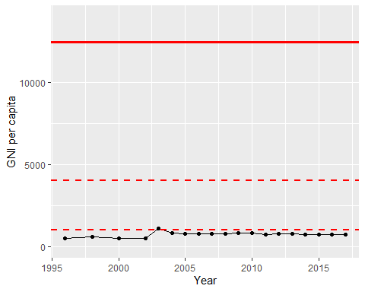

GNI Per Capita Trend